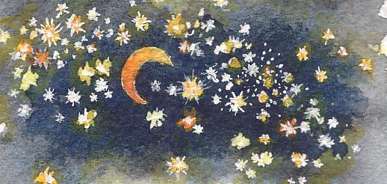
TIMELINE NOTES

Creation
The aim of the Bible is to introduce us to God's plan of salvation, not to explain how He created the universe.
God exists outside of time and space, as we know it. So, while God created the physical universe, He could see all of human history. While He caused the aggregation of galaxies, he saw His infant son crying in Mary's arms, and while He created the primordial universal radiation, He saw His saints collectively praising His name in the finality of the kingdom of God.
Gen1:14 states that the reasons for the lights in the sky are for light, and for time measurement. Days are marked by the earth's rotation, months by the moons revolution, and years by the earth's revolution about the sun. Rev 21:22-23 talks of the Kingdom without sun and moon - perhaps it is the measurement of time, or time itself, which is ended.
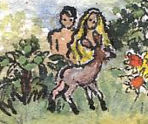
God set the sun, moon and stars in their positions in heavens, relative to earth. In Genesis they have the role of giving light to the world, and of marking the passage of time. John’s gospel tells us that Jesus was the true light that came into the world and was part of God’s plan from the beginning.
Adam and Eve
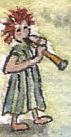
God created man in His image to fill the earth with His glory, but not obeying God meant that sin entered the world. God did not leave Adam and Eve without hope and made some promises to them which pointed forward to Jesus as their saviour and the one who would overcome sin and destroy it’s power. It was not long before jealousy also entered the world and Cain murdered his righteous brother Abel. Seth seemed to take Abel’s place and there seems to be a line of righteous people known as the “Sons of God” and a line of unrighteous people who produced “the Daughters of men”. Before the flood people lived very long lives. It is recorded that Cain built a city : that Jabel dwelt in tents and had cattle, Jubal was the father of those who played the harp and flute & Tubal Cain forged tools from bronze and iron.
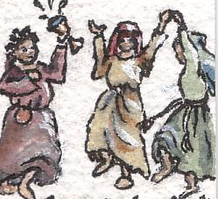
Noah
By the time Noah was born it seems that the righteous had mingled with the unrighteous – this time was called “the days of Noah” by Jesus. Out of all the people on the earth only Noah was righteous before God.
The Flood

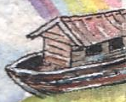
The wickedness of man was so great that God decided to destroy man from the earth except for Noah and his family.

The Tower of Babel
It is amazing that the first major event recorded after the flood was the building of the Tower of Babel. How soon man had reverted to his old bad ways. It was at this point that God made people speak in different languages. People spread out and formed groups with those they understood. Cities were built and places to worship their false Gods.
Abraham
God saw that Abraham was a man of faith and told him to leave the city he was living in and to go to a new land. He made key promises to Abraham that effect how we understand much of what came after. Abraham was promised a blessing through Isaac – the promised son by Sarah- but the ultimate blessing through Jesus. Abraham also had other sons, Ishmael through Hagar and 6 others with Keturah.... they were the ancestors of some of the Arab nations, but Isaac was the ancestor of the Jewish nation.
Jacob and Esau

Jacob and Esau were twins, they were Abraham’s grandsons. It was not Esau the firstborn who the promises would go through, but Jacob. God said that the elder would be ruled by the younger. Esau became the father of some more Arab nations, and Jacob had 12 sons who eventually became the 12 tribes of Israel (God changed Jacob’s name to Israel). Joseph was the 2nd youngest son and favoured by his father. Because his brothers were jealous they sold him. God blessed him and made him prosper in Egypt and helped prepare the way for all the others when they had learnt their lessons and their characters had improved. A drought forced the whole family to Egypt.
Moses
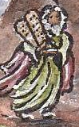
After the Israelites had been in Egypt for 400 years God saw their affliction and chose Moses to lead them out. Moses could have had the treasures of Egypt. Hebrews 11 tells us “Moses refused to be known as the son of Pharaohs daughter...He regarded disgrace FOR THE SAKE OF CHRIST as of greater value than the treasures of Egypt”. Moses turned his back on worldly wealth and fame, but he gained a treasure that was far greater. He knew that his hope was in the future and understood the promises about Jesus.
The Promised Land
Due to their lack of faith God made the Israelites wander in the desert for 40 years. It seems that during this time Moses wrote the first 5 books of the Bible that have become known as the “Torah” (meaning law, instruction, commandments) or the Pentateuch (5 volumed book). God gave Moses the 10 commandments and other laws for them to live by. God wanted people to serve him from their hearts, but in case they didn’t, they had the law to make them do the right thing. But keeping the law became an obstacle in itself as some saw that obedience to rules was what God wanted and would gain them righteousness, rather than doing the right thing from love. John 1 v 17 tells us that “the Law was given by Moses, but grace and truth came by Jesus Christ.”
Moses came to represent the law. It would not be someone who represented the law that lead the Israelites into the promised land, but Joshua who was a type of Jesus. The Israelites were faithful to God under the leadership of Joshua, but after he died and those of his company, some of the Israelites sank back into bad ways.
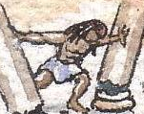
Judges

There was a period when Judges ruled Israel and every man did what was right in his own eyes. There were faithful men and women in this period such as Deborah, Barak and Sampson.
The Kingdom of Israel
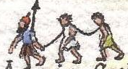
God’s plan had been for the Israelites to be a light to the nations, to convert the rest of the world, and for a short time the Kingdom of God had a type in the kingdom of Israel. Saul became the first king followed by David “a man after God’s heart”. God made more key promises to David that his greater descendant (Jesus) would eventually sit on his throne. Solomon was king after David and Israel rose to its greatest period of prosperity. Solomon built the temple in Jerusalem.
The Captivity
The peaceful period did not last and after Solomon’s death the Kingdom was split and became known as Israel in the North and Judah in the South. Jerusalem was part of the kingdom of Judah. The Israelites again turned away from God so He allowed them to be taken into captivity by other nations.
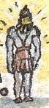
Daniel’s Visions
Daniel was captured and taken to Babylon. It was while he was there that God revealed to him amazing visions of the future concerning those who would rule the areas centred around Israel – the great World Empires of the times to come. The detail and accuracy of these prophecies is more proof that God exists, is in control, and knows the future. (a chart of Daniel’s prophecies is available separately)
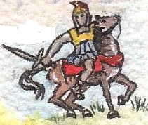
As God had told Daniel in advance, Israel was successively ruled by the Babylonians, the Medes & Persians, the Greeks, the Romans, mixed nations, and then finally will be Jesus.
The Maccabees
In 167 BC Antiochus Epiphanes desecrated the temple in Jerusalem. A pig was sacrificed and false Gods worshipped. Matthias Maccabeas was the high priest and began a rebellion with his five sons. Matthias died but his son Judas took over and the temple was eventually cleansed by the Jews who regained the control of Jerusalem. Judas won a victory over the Syrian general Nicanor, and negotiated a treaty with Rome. Daniel had prophesied that “The people who know their God shall be strong”. The Jews commemorate the triumph of Judas with an annual feast called “Hanukkah”.
Some Jews did not like the Maccabean rulers who were both priests and military leaders, and started their own community at Qumram where the 'Dead Sea Scrolls' were found. The Maccabeans ruled for about 100 years. Different political groups arose called the Pharisees and Saducees.

The Romans

In 63 BC The Roman general Pompey took control of Jerusalem. The sacrificial practices were resumed under Roman rule.
It is important to understand this period in order to understand the political scene in NT times.
Jesus Christ
“And the word was made flesh and dwelt among us, and we beheld His glory, the glory as of the only begotten Son of the Father, full of grace and truth.” Jesus came as the light of the world... the one anticipated since the promise to Adam and Eve... the seed promised to Abraham and the prophesied son of David. God’s plan from the beginning to be the only way we can be saved.

